# Stakeholder and Decision Maker Report: Cybersecurity Risk & Compliance Assessment for Clemons Business Group, Inc

**Date**: 11/26/2024

**Prepared by**: Josiah Umezurike (Each1Teach1 Tech)

**Purpose**: This report serves as a preliminary overview of Clemons Business Group, Inc's cybersecurity posture, focusing on its current organizational and system security analysis as part of the Security Operations Center (SOC) framework. It outlines critical risks, identifies compliance gaps, and provides initial recommendations to strengthen the security infrastructure, with an emphasis on continuous monitoring, detection, and incident response.

# Executive Summary

This preliminary report highlights the current cybersecurity state of Clemons Business Group, Inc, with an emphasis on assessing its organizational and system security posture. While this is an initial overview, it is part of a larger effort to align security controls with industry compliance standards, regulations, and best practices. The purpose of this report is to illustrate the need for comprehensive monitoring, threat detection, and an effective incident response system, which are fundamental components of a mature SOC infrastructure.

It is important to note that this report does not fully address all areas of security that are required for comprehensive risk mitigation. More detailed and focused assessments will be necessary to bring the organization up to the desired level of compliance with standards such as PCI-DSS, HIPAA, GDPR, and SOC 2.

# Mode of Operation & Security Risks

**Primary Areas of Operation:**

* **Website & Social Media Presence**
* **POS Systems & Cellular Data Networks**
* **Email Communication (Without Website)**
* **Internet Access through ISP/Mobile Data/Hotspots**

**Identified Security Risks:**

1. **Phishing & Spoofing**: Cybercriminals can exploit weak points in website and social media security to deceive users into disclosing sensitive information.
2. **Data Privacy Breaches**: Inadequate controls around social media accounts and POS systems can lead to unauthorized access and leaks of personal data.
3. **Malware & Hacking**: Without robust defenses, external threats such as malware and hacking can compromise both systems and data.
4. **Account Hijacking**: Cyber attackers could target social media platforms to impersonate the organization, leading to reputational damage and data compromise.

**Potential Vulnerabilities:**

1. **Weak Authentication & Lack of MFA**: Weak login mechanisms increase the risk of unauthorized access to critical platforms.
2. **Unpatched Systems & Software**: Vulnerabilities in outdated software or unpatched systems are prime targets for cyberattacks.
3. **Unsecured File Uploads & APIs**: Web application flaws that allow for insecure data exchange can be exploited to steal or corrupt data.
4. **Misconfigured Network Services**: Poorly configured servers and cloud services expose the system to potential breaches.

# Compliance and Regulatory Requirements

**Industry Standards & Regulations:**

* **PCI-DSS**: Mandatory for companies dealing with cardholder data to protect payment systems.
* **HIPAA**: Relevant for healthcare organizations that store or transmit protected health information (PHI).
* **CMMC**: Essential for defense contractors to meet cybersecurity maturity model standards.
* **GDPR & CCPA**: Enforce data privacy and protection for organizations operating in or dealing with data from the EU and California.
* **SOC 2, ISO/IEC 27001**: These standards define the processes for safeguarding sensitive data and ensuring continuous monitoring.
* **FTC Safeguard Rules**: Focused on the protection of financial data, applicable to financial institutions and service providers.

# SOC Framework: Monitoring, Detection, and Incident Response

As part of Clemons Business Group, Inc's SOC strategy, monitoring and detection must be continuously integrated into the cybersecurity framework. The implementation of a robust incident response plan is critical to manage potential threats efficiently. This assessment focuses on the need for:

* **Continuous Monitoring**: Leveraging a SOC model ensures real-time detection of anomalies and potential threats, enabling proactive defense.
* **Threat Detection**: Implementing tools such as SIEM (Security Information and Event Management), IDS/IPS, and network flow analyzers to continuously scan for threats.
* **Incident Response Plan (IRP)**: Developing a comprehensive IRP that can be activated immediately to mitigate the effects of a cyberattack, minimize downtime, and restore operations.

# Security Threats & Mitigation Strategies

**Potential Security Risks:**

1. **Phishing and Social Engineering:** Cybercriminals often target employees or customers through emails, phone calls, or fake websites to gain unauthorized access to sensitive systems or data. These tactics exploit human vulnerabilities.
2. **DDoS Attacks (Distributed Denial of Service):** Malicious actors may overload the website or network services, rendering them unavailable to legitimate users, disrupting operations, and potentially causing reputational damage.
3. **Reputational Damage via Social Media:** Compromised social media accounts can be used to spread misinformation or engage in malicious activities that damage the organization’s public imag**e.**

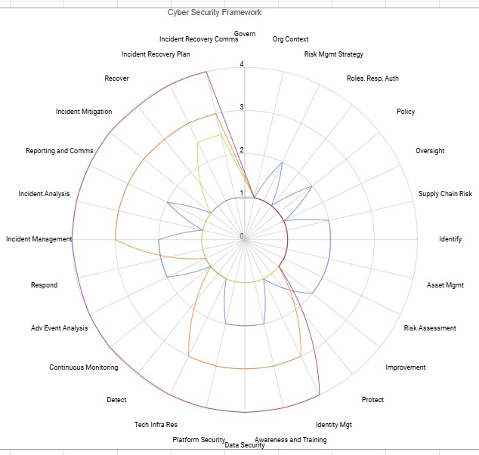

Legend:

**Mitigation Strategies:**

1. **Access Control Policies:** Implement strict access control measures and enforce multi-factor authentication (MFA) for all critical systems to ensure only authorized personnel can access sensitive data and systems.
2. **Regular Software Updates & Patches:** Continuously update all software and systems, patching vulnerabilities to prevent exploitation by cybercriminals. Ensure both in-house and third-party systems are up-to-date.
3. **Employee Training:** Invest in regular training to help employees recognize phishing attempts, social engineering tactics, and how to report suspicious activities. Awareness is a key component in preventing these types of attacks.
4. **Incident Response Plan (IRP):** Develop and implement an incident response strategy that outlines clear procedures for detecting, containing, and mitigating cybersecurity threats in real-time. This will help minimize damage and downtime in the event of an attack.
5. **SOC Monitoring:** Establish continuous monitoring via a Security Operations Center (SOC), utilizing automated tools and threat detection systems (SIEM, IDS/IPS) to identify unusual activity early and respond swiftly to potential threats.

# Key Recommendations

1. **Improve Web Security**: Ensure regular software patches, secure coding practices, and the use of encryption protocols to safeguard against web vulnerabilities.
2. **Enhance Data Privacy Controls**: Deploy data encryption, regular security audits, and comply with GDPR and other privacy regulations to safeguard user information.
3. **Establish Real-Time Monitoring**: Implement a comprehensive SOC that provides continuous monitoring for unusual activity and rapid incident detection.
4. **Train Employees on Cyber Hygiene**: Ongoing security awareness programs for all employees, especially regarding phishing, social engineering attacks, and safe handling of sensitive data.
5. **Strengthen Authentication Mechanisms**: Enforce multi-factor authentication (MFA) across all critical systems to reduce the likelihood of unauthorized access.

**Cybersecurity Risks management:**

# Conclusion

This report outlines the preliminary cybersecurity risks and compliance gaps at Clemons Business Group, Inc. While not exhaustive, it underscores the importance of moving forward with a comprehensive SOC infrastructure, robust incident response strategies, and continuous security monitoring to achieve compliance and mitigate potential cyber threats. The next steps will involve further detailed assessments and the refinement of the security posture to meet industry standards and regulatory requirements.

**Prepared by**: Josiah Umezurike jumezurike@each1teach1.us

Cybersecurity Risk and Compliance Assessment **Approved by**:

Lewis Duffie

Snr. Advisor

This preliminary report establishes the foundation for building a resilient cybersecurity framework and sets the stage for a more detailed and comprehensive security posture analysis in the future.